

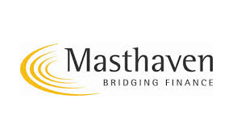

Masthaven launches hybrid 2nd charge short term product

Masthaven Group has launched a product, which is a unique fusion of bridging and secured loan. It is particularly aimed at helping intermediaries with clients requiring access to fast funding for credit repair, immediate payment of tax bills and school fees as well as many more traditional bridging finance applications.

Bringing together expertise from the bridging and secured loan divisions of the company, the product has many features, which will appeal to intermediaries and their clients.

Features include: -

- Loans up to £250,000

- Secured against residential property

- Maximum term 12 months

- Up to 6 units of adverse credit (depending on exit)

- Refinance to longer term as a secured loan subject to status

Paul Brett, Director of Sales of Masthaven Secured Loans, said, “ We are particularly proud to bring this new product to market, as it demonstrates how the bridging and secured loan sectors can cooperate to the advantage of the customer. This initiative plugs a gap that we identified with feedback from our bridging and second charge introducers. Masthaven is showing that innovation and lateral thinking in designing lending solutions will be at the heart of our strategy in 2014.”

Richard Deacon, Sales Director for Masthaven’s bridging division commented, “ As a company, we are committed to being quick to recognise opportunities to offer innovative product solutions, and this new collaboration will be the first of a number of initiatives from Masthaven. Brokers look to lenders for different strengths and we are a company building a deserved reputation as a product ground breaker backed by a strong service ethic.”

Ends

